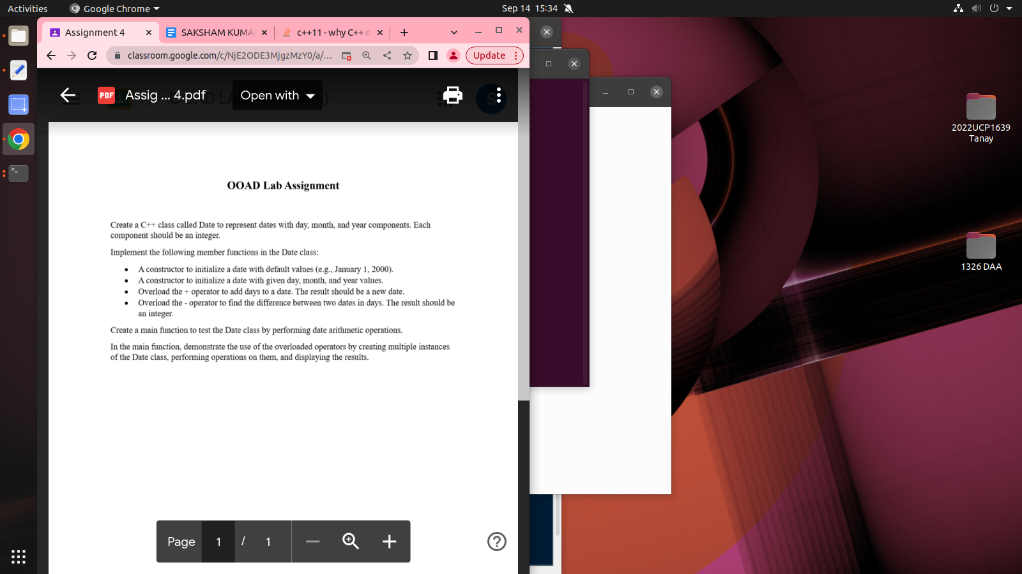

//code:-

#include<iostream>

#include<vector>

using namespace std;

vector < string > months = {

"January",

"February",

"March",

"April",

"May",

"June",

"July",

"August",

"September",

"October",

"November",

"December"

};

class Date {

int day;

int month;

int year;

public:

Date();

Date(int day, int month, int year);

void setday(int day);

void setmonth(int month);

void setyear(int year);

int getday();

int getmonth();

int getyear();

void display();

Date operator + (int day);

friend int operator - (Date & , Date & );

};

Date::Date() {

day = 1;

month = 1;

year = 2000;

}

Date::Date(int day, int month, int year) {

this -> day = day > 0 && day <= 31 ? day : 1;

this -> month = month > 0 && month < 13 ? month : 1;

this -> year = year > 0 ? year : 2000;

}

void Date::setday(int day) {

if (day > 0 && day <= 31)

this -> day = day;

}

void Date::setmonth(int month) {

if (month > 0 && month < 13)

this -> month = month;

}

void Date::setyear(int year) {

if (year > 0)

this -> year = year;

}

int Date::getday() {

return day;

}

int Date::getmonth() {

return month;

}

int Date::getyear() {

return year;

}

void Date::display() {

cout << months[month - 1] << " " << day << ", " << year << endl;

}

Date Date::operator + (int day) {

int new_day = this -> day + day;

int new_month = this -> month;

int new_year = this -> year;

if (new_day > 31) {

new_month += new_day / 31;

new_day = new_day % 31;

if (new_month > 12)

new_year += new_month / 12;

}

Date new_date(new_day, new_month, new_year);

return new_date;

}

int operator - (Date & d1, Date & d2) {

return d1.getday() - d2.getday();

}

int main() {

Date date1;

Date date2(5, 4, 2020);

Date date3;

cout << "Date1:- ";

date1.display();

cout << "Date2:- ";

date2.display();

int Diff_day = date2 - date1;

cout << "Difference between days of date2 and date1 is:- " << Diff_day << endl;

int day;

cout << "Enter day to add:- ";

cin >> day;

date3 = date1 + day;

cout << "After add Date1 with " << day << " New Date:- ";

date3.display();

return 0;

}